ComStock Measure Documentation:
Lighting Control for Emissions Reduction
Jie Xiong and Janghyun Kim



Acknowledgments
The authors would like to acknowledge the valuable guidance and input provided by Christopher CaraDonna, Matt Leach and Chioke Harris at the National Renewable Energy Laboratory, Andrew Huck from Michaels Energy and Rodney Sobin from NASEO-NARUC.

List of Acronyms
Btu British thermal units
CBECS Commercial Buildings Energy Consumption Survey
DR demand response
EIA U.S. Energy Information Administration
EUI energy use intensity
GEB grid-interactive efficient building
HVAC heating, ventilating, and air conditioning
LRMER long-run marginal emissions rate
RE renewable energy
URDB Utility Rate Database
TOU time of use

Executive Summary
Building on a 3-year effort to calibrate and validate the U.S. Department of Energy’s ResStock™ and ComStock™ models, this work produces national datasets that empower analysts working for federal, state, utility, city, and manufacturer stakeholders to answer a broad range of questions regarding their commercial building stock.
ComStock is a highly granular, bottom-up model that uses multiple data sources, statistical sampling methods, and advanced building energy simulations to estimate the annual subhourly energy consumption of the commercial building stock across the United States. The baseline model intends to represent the U.S. commercial building stock as it existed in 2018. The methodology and results of the baseline model are discussed in the final technical report of the End-Use Load Profiles project.
The goal of this work is to develop energy efficiency, electrification, and demand flexibility end-use load shapes that cover high-impact, market-ready (or nearly market-ready) measures. “Measures” refer to various “what-if” scenarios that can be applied to buildings.
An end-use savings shape is the difference in energy consumption between a baseline building (or collection of buildings) and a building with an energy efficiency, electrification, or demand flexibility measure applied. It results in a time-series profile broken down by end use and fuel (electricity or on-site gas, propane, or fuel oil use) at each time step, as well as annual aggregations.
This report describes the modeling methodology for a single end-use savings shape measure—lighting control for emissions reduction—and briefly introduces key results. The full public dataset can be accessed on the ComStock data lake or via the Data Viewer at comstock.nrel.gov. The public dataset enables users to create custom aggregations of results for their use case (e.g., filter to a specific county).
Key modeling assumptions and technology details are summarized in Table ES-1.
Table ES-1. Summary of Key Modeling Specifications
Technology description | - The lighting control for emissions reduction measure applies lighting dimming control to reduce the lighting load during the building’s emissions peak window every weekday.  - The measure takes daily peak emissions schedule inputs generated by the method “Dispatch Schedule Generation” described in End-Use Savings Shapes Measure Documentation: Dispatch Schedule Generation for Demand Flexibility Measures to determine the start and end times of the predicted peak window, and then adjusts the lighting dimming level by a percentage reduction from the original schedules during the peak window to reduce greenhouse gas emissions.
Performance assumptions | - By default, the peak window length is set to be 4 hours.  - The measure is flexible and allows users to adjust the lighting dimming percentage value.  - The default adjustments in this study are set to −30%. This means the lighting power is reduced by 30% compared to the baseline model during the dispatch periods.  - The lighting levels are set back to original schedule values after the peak window.
Applicability | - This measure is applicable to large, medium and small offices; warehouses; and primary and secondary schools.  - This measure is applicable to approximately 68.00% of the stock floor area.
Release | - 2025 Release 1: 2025/comstock_amy2018_release_1/

National annual results for site energy, greenhouse gas emissions, and energy bills are summarized in Table ES-2–ES-4. Note that these summary tables for greenhouse gas emissions and energy bills use one of many respective scenarios. Other scenarios are discussed later in the report, with further scenarios available in the ComStock public dataset.
Table ES-2. Summary of Key Results for Annual Site Energy Savings
Fuel Type | Percent Savings (All Buildings) | Percent Savings (Applicable Buildings Only) | Absolute Savings (TBtu)ª
Natural gas | -0.36% | -0.81% | −5.4
Electricity | 0.71% | 1.48% | 22
ª Trillion British thermal units

Table ES-3. Summary of Key Results for Annual Greenhouse Gas Emissions Savings.
Electricity emissions avoided in this table are calculated using the Cambium Long-Run Marginal Emissions Rate (LRMER) High Renewable Energy Cost 15-Year grid scenario. Other grid scenarios are presented in this report and in the public dataset.
Fuel Type | Percent Savings (All Buildings) | Percent Savings (Applicable Buildings Only) | Absolute Savings (MMT CO₂e)ª
Natural gas | -1.0% | -1.6% | -1
Electricity | 0.9% | 1.8% | 2
Fuel oil | 0.0% | 0.0% | 0
Propane | 0.0% | 0.0% | 0
Total | 0.3% | 1.1% | 1
ª Million metric tons of carbon dioxide equivalent.

Table ES-4. Summary of Key Results for Annual Utility Bill Savings.
Electricity bill savings in this table are calculated using the mean electricity rate available for each building. Other electricity rate structures are available in this report and in the public dataset.
End Use/Fuel Type | Percent Savings (All Buildings) | Percent Savings (Applicable Buildings Only) | Absolute Savings (Million USD, 2022)
Electricity | 1.0% | 1.2% | 1
Natural gas | 0.0% | 0.0% | 0
Fuel oil | 0.0% | 0.0% | 0
Propane | 0.0% | 0.0% | 0
Total | 0.8% | 1.0% | 1

Table of Contents
Executive Summary v
1 Technology Summary 1
1.1 Grid-Interactive Efficient Buildings With Demand Flexibility 1
1.2 Lighting Control Strategies for Demand Flexibility 1
2 ComStock Baseline Approach 4
3 Modeling Approach 8
3.1 Applicability 8
3.2 Technology Details 10
3.3 Greenhouse Gas Emissions 10
3.4 Utility Bills 11
3.5 Limitations and Concerns 12
4 Output Variables 14
5 Results 16
5.1 Single Building Measure Tests 16
5.2 Stock Demand Flexibility Performance for Emissions Reduction 19
5.3 Stock Energy Impacts 21
5.4 Stock Utility Bill Impacts 22
5.5 Site Energy Savings Distributions 24
References 26
Appendix 29

List of Figures
Figure 1. “Truth” lighting generation distribution (0–1) and comparison of 2017 and 2020 ComStock sampling results 6
Figure 2. Example weekday lighting schedules (fractional factor to fully ON) 7
Figure 3. Floor area prevalence of building types and applicability for each building type 9
Figure 4. Building count prevalence of building types and applicability for each building type 9
Figure 6. Comparison of load profiles, emission profiles, and lighting schedules (baseline and lighting load shed) for emission reduction for test small office model 18
Figure 7. Greenhouse gas emissions comparison of the ComStock baseline and the lighting control for emissions reduction scenario 20
Figure 8. Distributions of percentages of daily emissions reduction by season compared to the baseline scenario, with Cambium LRMER Mid Case 15-Year scenario 20
Figure 9. Comparison of annual site energy consumption between the ComStock baseline and the lighting control for emissions reduction measure scenario, for the whole stock (left) and applicable buildings only (right). Energy consumption is categorized both by fuel type and end use. 21
Figure 10. Stock annual utility bill comparison of the ComStock baseline and the lighting control for emissions reduction scenario. Three sets of bill costs are presented: maximum electricity rate, mean electricity rate, and minimum electricity rate. 22
Figure 11. Distribution of annual electricity bill savings compared to the baseline model for maximum, mean, and median bills (for applicable buildings) 23
Figure 12. Percent bill savings for ComStock models with the lighting control for emissions reduction upgrade by fuel types. The data points that appear above some of the distributions indicate outliers in the distribution, meaning they fall outside 1.5 times the interquartile range. The value for n indicates the number of ComStock models that were applicable for energy savings for the fuel type category. 24
Figure 17. Percent site energy savings distribution for ComStock models with applied measure scenario by end use and fuel type. The data points that appear above some of the distributions indicate outliers in the distribution, meaning they fall outside 1.5 times the interquartile range. The value for n indicates the number of ComStock models that were applicable for energy savings for the fuel type category. 25
Figure 18. Percent site energy use intensity savings distribution for ComStock models with applied measure scenario by end use and fuel type. The data points that appear above some of the distributions indicate outliers in the distribution, meaning they fall outside 1.5 times the interquartile range. The value for n indicates the number of ComStock models that were applicable for energy savings for the fuel type category. 25
Figure A-1. Site annual natural gas consumption of the ComStock baseline and the measure scenario by census division 29
Figure A-2. Site annual natural gas consumption of the ComStock baseline and the measure scenario by building type 29
Figure A-3. Site annual electricity consumption of the ComStock baseline and the measure scenario by building type 30
Figure A-4. Site annual electricity consumption of the ComStock baseline and the measure scenario by census division 30

List of Tables
Table ES-1. Summary of Key Modeling Specifications v
Table ES-2. Summary of Key Results for Annual Site Energy Savings vi
Table ES-3. Summary of Key Results for Annual Greenhouse Gas Emissions Savings. vi
Table ES-4. Summary of Key Results for Annual Utility Bill Savings. vii
Table 1. Lighting Generations and Associated Technologies for Each Category 4
Table 2. Average Building-Level Lighting Power Density (W/ft²) by Lighting Generation and Building Type 5
Table 3. On-Site Fossil Fuel Emissions Factors 11
Table 4. Summary Statistics of Utility Bill Implementation in ComStock by Fuel Type 11
Table 5. Output Variables Calculated From the Measure Application 14
Table 6. Default Options for Measure Parameters 16
Table . Summary of Site Energy Savings From Upgrade Measure Application vs. the ComStock Baseline 21

- Technology Summary
The lighting control for emissions reduction measure applies lighting dimming control to reduce the lighting load and corresponding greenhouse gas emissions during the peak window every weekday. The measure takes daily peak load schedule inputs generated by the method “Dispatch Schedule Generation” described in End-Use Savings Shapes Measure Documentation: Dispatch Schedule Generation for Demand Flexibility Measures (on the ComStock webpage) to determine the start and end times of the predicted peak window, and then adjusts the lighting level by a percentage reduction from the original schedules during the peak window to reduce the peak demand.
  - Grid-Interactive Efficient Buildings With Demand Flexibility
Electricity consumers across the residential, commercial, and industrial sectors are increasingly interested in opportunities to reduce their electricity bills and carbon footprint. Simultaneously, utilities, system operators, and state decision makers are aiming to reduce costs, more effectively utilize existing grid assets, maintain power system reliability, and reach carbon reduction targets. At the intersection of the customer and utility perspectives, buildings and their associated loads offer opportunities to align the interests of consumers, system operators, and policy decision makers. Interactivity between buildings and the broader electricity system expands these opportunities, and is enabled by advancements in building control technologies, data availability, advanced metering, new tariff designs, and improved analytics for energy management. Collectively, these smart technologies for energy management are often referred to as grid-interactive efficient buildings (GEBs). GEBs utilize high-efficiency components to reduce electricity demand and increase the flexibility of specific building loads, respond to real-time signals or advanced calls for demand response, or target bill savings associated with demand regulations such as time-of-use rates and rates with demand charges. By shedding and shifting building load, these GEBs can reduce electricity bills, the cost of operating the grid, and emissions, all while maintaining the comfort of building occupants.
Many studies have been devoted to building control for grid services [1], [2], [3], [4], [5], [6], [7], [8], [9], [10]. There are five technical interventions or measures used in a building’s demand profile modification in the literature [11], [12], [13], [14], [15], [16], [17]. The first, energy efficiency, refers to techniques that help reduce the net demand during both on-peak and off-peak periods. The second, peak shaving or load shedding, refers to reducing the on-peak demand (i.e., when the demand in the power grid is high). The third method is load shifting, which means altering the demand profile to meet certain performance criteria, usually involving a reduction in on-peak demand and an offset by a load increase at a different time. The fourth method is renewable energy, which utilizes distributed energy resources to coincidently reduce on-peak demand. The last is modulation, which provides rapid adjustments to regulate frequency and voltage and ensure power quality. The existing methods that fall within these five categories can help reduce demand charges directly or indirectly.
  - Lighting Control Strategies for Demand Flexibility
Lighting systems were reported to consume 10.4% of all energy and 17.4% of electricity in commercial buildings in 2018 [18], making them the second largest contributors to commercial electricity use (slightly less than ventilation systems). Lighting systems thus have great potential for load management. Lighting loads in commercial buildings are dependent on the space type, schedule, and lighting technology type (e.g., ballast type), but the lighting load profiles usually share similar or consistent daily patterns across commercial buildings (according to daily operating patterns, such as weekday or weekend operation), which yields great demand flexibility potential. The GEB technical report series [19] evaluates that advanced sensors and controls of lighting system have high potential for grid interaction capability.
Compared to heating, ventilating, and air-conditioning (HVAC) systems, currently installed lighting systems are less automated—approximately 6% of commercial buildings have building automation systems for lighting in the United States [18]—so it is more difficult to achieve load flexibility strategies through existing automated lighting controls. However, advances in lighting technologies have led to cost-effective intelligent lighting control applications via lighting-application-specific controllers coupled with Internet of Thing and wireless technologies, as well as controllable lighting products such as dimmable ballasts or LEDs. The U.S. General Services Administration reports that advanced lighting controls reduce LED lighting energy use by 43% [20], and retrofitting fluorescents to LEDs yields a 40% investment return [21]. Therefore, low-cost retrofitting to control existing lighting systems in commercial buildings is possible. By 2035, the U.S. Department of Energy projects that one-third of lighting in the commercial sector will be connected to the grid, driven by energy codes, utility rebates, energy savings, and non-energy benefits driven by data and analytic capabilities [19].
Lighting systems have two advantages for demand flexibility capability. First, adjusting lighting energy use can be nearly instantaneously realized with lighting controls, which makes lighting systems one of the most reliable, elastic, and responsive end uses for dynamic load management. Lighting systems are one of the two major targets (the other is thermostats) for demand response programs, through either direct load control/override by utilities or incentive-regulated user response. Second, the amount of light dimming required to productively reduce electric loads does not need to compromise occupant comfort. Various studies [22], [23], [24], [25] have suggested that reducing lighting levels from the recommended values within a certain range (13%–25%) is acceptable without occupants noticing it or causing significant visual discomfort, for a short duration (hours).
Although energy efficiency measures regarding overall minimization of lighting energy use could be designed based on such fact, it is not the target of discussion in this measure documentation. Other factors affecting visual comfort and productivity such as light levels and glare, or affected by surrounding environment such as windows and fenestration systems, are assumed to be taken into account in the ComStock baseline approach. This approach generates the original lighting schedules described in next section, and demand flexibility potential lies upon these factors without significant interference.
Typical lighting control methods include on/off control, (discretized) multilevel control, and (continuous) dimming control. Modern lighting products such as fluorescent fixtures with dimmable ballasts and LEDs are designed to enable continuous dimming, which is very common in the market nowadays, while on/off or multilevel controls can approximate (stepped) dimming by properly grouping/clustering design of the controlled luminaires in a space, such as the proportional load shedding method presented in Husen et al. [26]. Studies related to lighting controls applied for demand flexibility are very limited due to the low penetration of automated lighting in the commercial sector. Case studies in California [27] quantified the demand savings of a single dimmable fixture to be 22.7–30 W from different reduction ranges (70% to 30% up to 100% to 50%), and the demand savings intensity of grouped control lighting to be 0.45 W/ft² by switching off a quarter of fixtures (equivalent to dimming from 100% to 75%). It also estimated 1-GW peak reduction potential for all commercial buildings in California by assuming a 20% lighting peak demand reduction goal is achieved. According to a report by the Lighting Controls Association [28], many large buildings (more than 10,000 ft²) built after 2016 in California are capable of at least 15% load reduction in case of a demand response event, partly through automated lighting control systems, to be compliant to the state’s Title 24 Building Energy Efficiency Standards (2016 version, Part 6—Energy Code). The Lighting Research Center at Rensselaer Polytechnic Institute and the New York State Energy Research and Development Authority conducted several demand response studies [29] in New York to apply ballast products with load shedding capability on both new and retrofitted buildings and demonstrated 25%–30% lighting load shed capability.

- ComStock Baseline Approach
This measure modifies the existing model interior lighting schedules during the daily peak demand windows (on-peak periods) only. For times outside of the event, the existing lighting schedules in the model are unchanged. The details of the lighting schedules, technology, and power in the existing ComStock models can be found in Section 4.2 “Hours of Operation and Occupancy” and Section 4.5.1 “Interior Lighting” in the ComStock Reference Documentation [30] for default schedules, as well as Section 3.3.4 “Interior Lighting Schedule Magnitude Variability” in the End-Use Load Profiles project report [31] for base-to-peak variation applied to the default lighting schedules.
ComStock interior lighting is determined by a lighting technology generation approach, with each generation representing a collection of lighting technologies typically installed during a given time period. ComStock assumes four categories of lighting: general (overhead lighting), task (lights focused on specific areas), supplemental (supplemental lighting), and wall wash (illuminates vertical surface). The lighting technologies used in each category across the ComStock lighting generations are listed in Table 1. Generations 4–8 represent varying efficacy levels of LEDs, with Generation 4 being the first LED technology to market, and Generation 8 being the estimated technology level in 2035.
Table 1. Lighting Generations and Associated Technologies for Each Category
Lighting Generation | General Lighting Technology | General Lighting (High Bay) Technology | Task Lighting Technology | Supplemental Lighting Technology | Wall Wash Lighting Technology
1 | T12 linear fluorescent | High-intensity discharge (HID) mercury vapor | Incandescent A-shape | Incandescent decorative | Incandescent decorative
2 | T8 linear fluorescent | HID metal halide | Halogen  A-shape | Halogen decorative | Halogen decorative
3 | T5 linear fluorescent | HID metal halide | Compact fluorescent screw | Compact fluorescent pin | Compact fluorescent pin
4–8 | LED linear | LED high bay luminaire | LED general purpose | LED decorative | LED directional

ComStock uses a similar approach to the ASHRAE 90.1 Lighting Subcommittee for determining the lighting power density allowance for a given space type. Table 2 provides the average installed building-level lighting power densities in ComStock by building type and lighting generation.
Table 2. Average Building-Level Lighting Power Density (W/ft²) by Lighting Generation and Building Type
 | Lighting Generation
Building Type | 1 | 2 | 3 | 4 | 5
full_service_restaurant | 1.51 | 0.96 | 0.45 | 0.43 | 0.39
hospital | 1.59 | 1.07 | 0.63 | 0.58 | 0.52
large_hotel | 1.31 | 0.80 | 0.29 | 0.23 | 0.21
large_office | 1.18 | 0.80 | 0.50 | 0.53 | 0.47
medium_office | 1.18 | 0.80 | 0.50 | 0.53 | 0.47
outpatient | 1.27 | 0.85 | 0.53 | 0.52 | 0.47
primary_school | 0.73 | 0.56 | 0.48 | 0.47 | 0.42
quick_service_restaurant | 1.73 | 1.11 | 0.56 | 0.52 | 0.47
retail | 1.17 | 0.75 | 0.54 | 0.47 | 0.42
secondary_school | 0.88 | 0.58 | 0.48 | 0.45 | 0.40
small_hotel | 1.08 | 0.63 | 0.28 | 0.25 | 0.22
small_office | 1.18 | 0.79 | 0.50 | 0.52 | 0.47
strip_mall | 1.59 | 1.07 | 0.65 | 0.64 | 0.59
warehouse | 0.83 | 0.40 | 0.39 | 0.30 | 0.27

Specifically, the lighting generations and corresponding technologies were assigned to each building model during the sampling process, based on validated distribution data (Figure 1), and introduced with variability representing realistic installation trends of different generations and impact of building sizes. Default interior lighting schedules come from the OpenStudio-Standards U.S. Department of Energy prototype building models [32]. The schedules are then adjusted with varying base-to-peak ratios to incorporate impact from characteristics such as building types and operating hours.
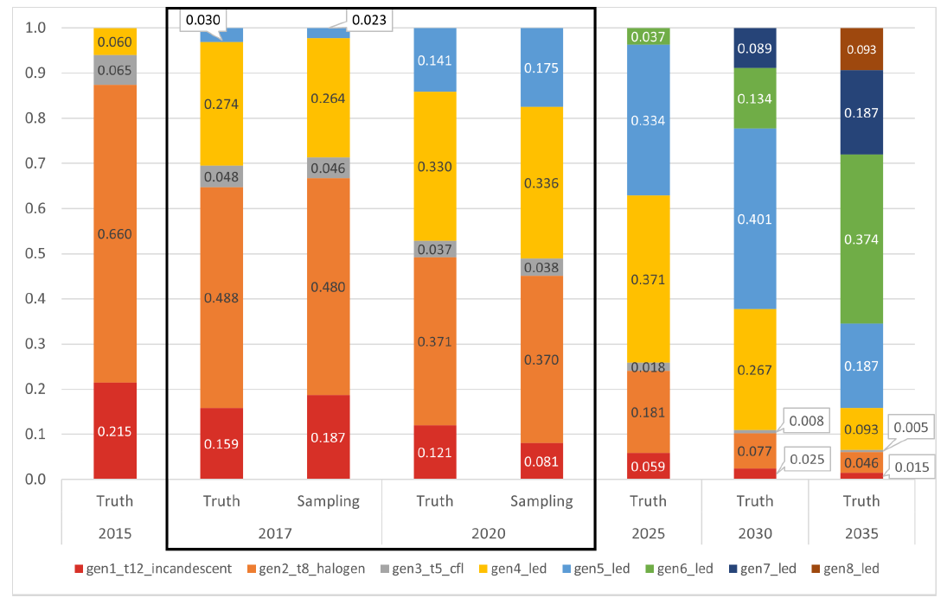
Figure 1. “Truth” lighting generation distribution (0–1) and comparison of 2017 and 2020 ComStock sampling results
Figure 2 shows two sets of example weekday lighting default schedules versus the corresponding base-to-peak ratio-adjusted schedules for large and small office buildings in the ComStock baseline models.
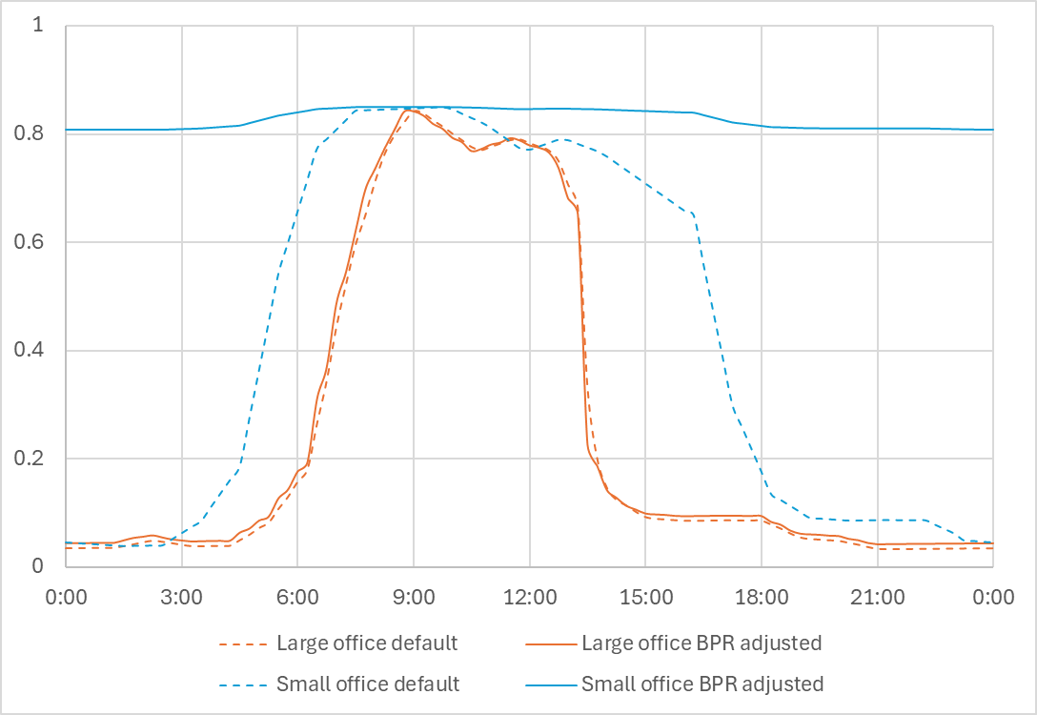
Figure 2. Example weekday lighting schedules (fractional factor to fully ON)

- Modeling Approach
  - Applicability
Despite of the existing low population of installed control systems for lighting in commercial buildings, this measure is likely applicable to most commercial building types as it targets lighting (schedule) control regardless of the details of lighting system operations. Based on the technical and practical references and feasibility evaluation of current ComStock models discussed below, we determine in this study the applicability of this measure to office buildings (small, medium, and large), warehouses, and schools (primary and secondary).
There are only a few resources that discuss the building and system type limitations of demand flexibility applications on commercial buildings. The ASHRAE GEB guide [18] states that hospital and laboratory buildings with specific temperature, humidity, and pressurization requirements are not suitable for demand flexibility HVAC control, and similarly, those buildings have specific lighting requirements for safety concerns such as the surgery space. It also points out that office buildings, high-rise multifamily buildings, and warehouses are ideal targets for demand flexibility applications because of their wider acceptable indoor environmental conditions. For retail/grocery stores and restaurants, customer satisfaction to lighting conditions becomes the priority, as it has a positive correlation with economic benefit, which yields fewer opportunities for demand flexibility that might compromise occupant comfort in peak periods. For example, darker conditions may affect customers’ willingness to consume. Great potential of lighting demand flexibility lies in hotels and schools when integrated with occupancy control (potential load flexibility varies with states of occupancy), but there are many aspects of practical considerations affecting the feasibility such as requirements specific to space type (e.g., gym, conference room) and weather-related operation issues (e.g., humidity/mold control), which require more rigorous research and design on actual application for these building types. Hotels have more distinctive lighting environment requirements between occupied and unoccupied rooms, and thus designing load management strategies for hotels relies heavily on occupancy control, which is out of the scope for this measure development study.
Moreover, different spaces in the same building would have different lighting condition requirements and might require different control strategies. For example, gym or laboratory spaces in schools have stricter light level requirements compared to classrooms or restrooms, leaving less room for dimming control. However, in this measure, it is reasonable to assume the control implementation is applicable to all the spaces in applicable buildings, regardless of space types, to ensure the generalizability of the measure in the stock level. This assumption is based on the approximation that the underestimated potential impact of the measure on some spaces (e.g., unoccupied rooms) would be offset by the overestimated impact on some other spaces with stricter lighting requirement (which correspond to an insignificant proportion of building area and loads) in a building with proper design of controls in practical applications.
This measure assumes the applicable buildings are or should be upgraded to be equipped with controllable lighting systems, as a prerequisite for lighting control, capable of meeting any specific dimming target via dimmable fixtures or proper design of control (e.g., turning off selective fixtures to achieve net dimming target).
Figure 3 shows the area percentage of large, medium, and small office buildings, primary and secondary schools, and warehouses among all the commercial building types in ComStock. Overall, 68.00% of the total stock floor areas are applicable for this measure. Figure 4 shows the building count percentage of the corresponding applicability, representing 2,800,013 or 59.29% of applicable buildings out of 4,722,342 buildings in the national stock level, with weighting factors applied. More specifically, 925,888 small offices, 98,309 medium offices, 33,119 large offices, 242,631 primary schools, 296,142 secondary schools, and 1,203,924 warehouses are applicable.
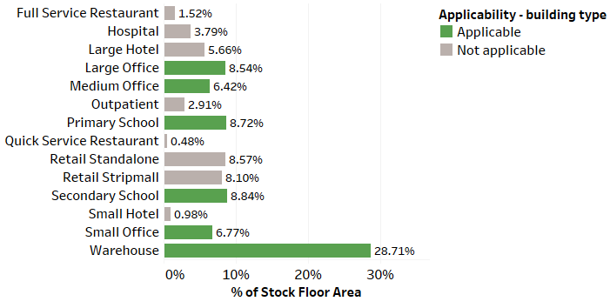
Figure 3. Floor area prevalence of building types and applicability for each building type

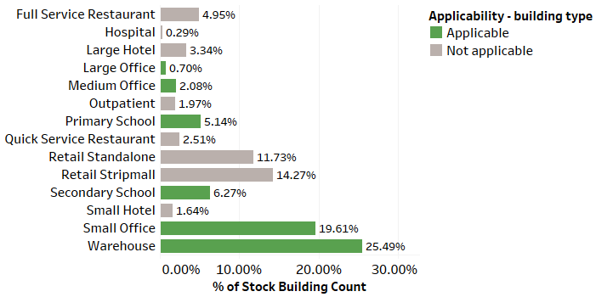
Figure 4. Building count prevalence of building types and applicability for each building type

  - Technology Details
    - Objective Selection and Input Schedule
The emission reduction objective targets the predicted emission profile and sheds electric load to reduce resulting emissions from electric power generation. With the selected objective, by applying the method “Dispatch Schedule Generation” described in End-Use Savings Shapes Measure Documentation: Dispatch Schedule Generation for Demand Flexibility Measures, a daily emission dispatch schedule will be generated and used as the input of this measure. Specifications of parameters for generating the peak schedule are defined in detail in the supplemental documentation. Specifically for the emission reduction objective, the daily dispatch windows are determined corresponding to the maximum aggregated predicted emissions within the window among multiple candidate windows that contain the peak emissions.
    - Lighting Schedule Generation
This measure clones all the schedules that are used for lighting. The cloned schedules are then adjusted by the specified percentage change during the peak window aligned with the input peak schedule. The adjusted schedules will be assigned to the corresponding lighting equipment to replace the original schedules in the model. The measure is flexible and allows users to adjust the dimming percentage, but for this study, the adjustment is set to be an absolute −30% change corresponding to the fully ON operating scenario of the lights by default according to the ASHRAE GEB guide [33]. For example, if at a given time the original lighting level is 80%, the adjusted level will be 50% instead of 56%. A minimum lighting threshold of 5% is set for this “absolute change” option in case the original lighting level is less than the default adjustment value (<30%), when a complete turn-off is not favorable or acceptable for safety considerations (e.g., corridor light). The option “relative change” is also available for the user to select, where the dimming percentage adjustment will correspond to the original lighting level. In the same example above, the adjusted lighting level will then be 56% with this option.
  - Greenhouse Gas Emissions
Three electricity grid scenarios are presented to compare the emissions of the ComStock baseline and the lighting control scenarios. More are available in the full public dataset. The choice of grid scenario will impact the grid emissions factors used in the simulation, which determines the corresponding emissions produced per kilowatt-hour. Two scenarios—Long-Run Marginal Emissions Rate (LRMER) High Renewable Energy (RE) Cost 15-Year and LRMER Low RE Cost 15-Year—use the Cambium dataset, and the last uses the eGrid dataset [34], [35]. All three scenarios vary the emissions factors geospatially to reflect the variation in grid resources used to produce electricity across the United States. The Cambium datasets also vary emissions factors seasonally and by time of day. This study does not imply a preference for any particular grid emissions scenario, but other analysis suggests that the choice of grid emissions scenario can impact results [36]. Emissions due to on-site combustion of fossil fuels use the emissions factors shown in Table 3, which are from Table 7.1.2(1) of draft American National Standards Institute/Residential Energy Services Network/International Code Council 301 [37]. To compare total emissions due to both on-site fossil fuel consumption and grid electricity generation, the emissions from a single electricity grid scenario should be combined with all three on-site fossil fuel emissions.
Table 3. On-Site Fossil Fuel Emissions Factors
Fuel | Emissions Factor
Natural gas | 147.3 lb/MMBtu (228.0 kg/MWh)ª
Propane | 177.8 lb/MMBtu (182.3 kg/MWh)
Fuel oil | 195.9 lb/MMBtu (303.2 kg/MWh)
ª MMBtu = million British thermal units
  - Utility Bills
ComStock provides utility bill estimates for several fuel types in buildings: electricity, natural gas, propane, and fuel oil. The current implementation represents utility bills circa 2022, which is the most current year of utility data available from the U.S. Energy Information Administration (EIA). This section provides a high-level overview of the methodology behind utility bills in ComStock, but more detailed information is available in the ComStock Reference Documentation [30]. Summary statistics from this implementation are shown in Table 4. Note that ComStock does not currently estimate utility bills for district heating and cooling.
Table 4. Summary Statistics of Utility Bill Implementation in ComStock by Fuel Type
Fuel Type | Minimum Price ($) | Average Price ($) | Maximum Price ($)
Natural gas | $0.070/kBtu | $0.012/kBtu | $0.048/kBtu
Propane | $0.022/kBtu | $0.032/kBtu | $0.052/kBtu
Fuel oil | $0.027/kBtu | $0.033/kBtu | $0.036/kBtu
Electricity | $0.003/kBtu | $0.035/kBtu | $3.530/kBtu
Natural gas bills are estimated using 2022 EIA averages by state. 2022 EIA natural gas prices (commercial price) and EIA heat content of natural gas delivered to consumers are used to create an energy price in dollars per thousand Btu [38].
Propane and fuel oil bills are estimated using 2022 EIA averages by state. Residential No. 2 distillate prices by sales type, EIA residential weekly heating oil and propane prices (October–March), and EIA assumed heat content for these fuels are used to create an energy price in dollars per thousand Btu [39]. Residential prices are used because commercial prices are only available at the national resolution. Additionally, most commercial buildings using these fuels are assumed to be smaller buildings in which a residential rate is likely realistic. For states where state-level pricing was available, these prices are used directly. For other states, Petroleum Administration for Defense District (PADD) average pricing is used. For states where PADD-level pricing is not available, national average pricing is used.
The primary resource for ComStock electric utility rates is the Utility Rate Database (URDB), which includes rate structures for about 85% of the buildings and 85% of the floor area in ComStock [40]. The URDB rates include detailed cost features such as time-of-use pricing, demand charges, and ratches. ComStock only uses URDB rates that were entered starting in 2013, and a cost adjustment factor is applied such that the rates reflect 2022 U.S. dollars.
URDB rates are assigned to ComStock models at the census tract level. The URDB can include several rate structures for a census tract. Instead of attempting to presume any single rate, multiple rates from the model’s census tract are simulated; the ComStock dataset includes the minimum, median, mean, and maximum simulated rates for each model.
Many precautions are implemented to prevent less reasonable rates from being applied. This includes removing noncommercial rates, rates with non-building-load keywords (e.g., security light, irrigation, snow, cotton gin), rates where the load profile does not follow any potential minimum/maximum demand or energy consumption qualifiers, and rates that cause suspiciously low (<$0.01/kWh) or high (>$0.45/kWh) blended averages. Additionally, any bill that is lower than 25% of the median or higher than 200% of the median is eliminated to avoid extreme bills.
For buildings with no URDB electric utility assigned, or for buildings where none of the stored rates are applicable, the annual bill is estimated using the 2022 EIA Form 861 average prices based on the state each model is located in [41]. While this method does not reflect the detailed rate structures and demand charges, it is a fallback for the 15% of buildings in ComStock with no utility assigned.
  - Limitations and Concerns
Below are the limitations and concerns for this measure that have been identified to date:
- This measure has a lower technology readiness level compared to other upgrade measures where the upgrade implementation (i.e., hiring contractor, purchasing/installing equipment) is readily available in the market. Our modeling is theoretical rather than being grounded in a specific product type, although the barrier of implementation of the proposed method is relatively low. We assume the upgrade to controllable and dimmable lighting system has negligible impact on the system energy performance, and the measure falls into a low-cost category due to independency on devices (it is control-oriented), and thus is theoretically and financially feasible.
- There are many possible estimation functions and dimming strategies that could be implemented, and this study chooses a single set of parameters that we consider to be reasonable and generalizable, but these choices will have an impact on results. First, this measure relies on the user-provided inputs of dispatch schedule, for which several options are developed and provided in the “Dispatch Schedule Generation” method. Different options yield distinctive dispatch time windows: perfect match to daily peak load (perfect prediction), a mimic of advanced application with uncertainty (bin sampling), or fixed dispatch schedules by season and region (fixed schedule). The performance of the measure with dispatch windows perfectly matching to daily peak load represents the “best scenario” of actual implementation of the measure in the real world, where daily peak load might be unpredictable. The differences in performance of different options and the limitations and concerns of the dispatch window generation method described in End-Use Savings Shapes Measure Documentation: Dispatch Schedule Generation for Demand Flexibility Measures also apply to the implementation of this measure. For example, the objective function generating daily dispatch windows could vary depending on measure, such as emission reduction or utility cost savings. The input parameters of a selected dispatch schedule generation method also play a significant role in the performance, such as dimming percentage value and length of peak window, and the impact may vary depending on building properties and weather conditions. We applied simple parametric analysis on the input parameters to justify the selection of default values, but detailed fine-tuning and other practical considerations are needed to determine the best parameter set(s) for specific building(s).
- The current scope of applicable building types is limited to offices, schools, and warehouses, with a simplified control strategy—uniform relative change throughout the building. As discussed in Section 3.1, different building types can have different practical concerns when applying demand flexibility strategies. For example, lighting controls in warehouses could have minimal impact on occupants due to low occupancy, while the occupancy distributions in schools are much more complicated and dynamic. The ranges of acceptable visual environment vary depending on the functions of spaces and real-time occupancy status. Such distinctions require careful and comprehensive research to transform the proposed strategy into practical applications, such as integration with occupancy sensor-based control (e.g. prioritizing comfort criterion in occupied space and turning lights off in unoccupied area). We have chosen applicability of building types assuming dimming in all contained space types in a building, and upgraded lighting technology to make demand flexibility control possible and generalizable. Such selection lost some extent of potential evaluation for a certain number of building types (e.g., hotels) that are not generalizable for now due to lack of technical references and standardizations (in stock level).
- This measure uses individual building-level daily peak load reduction or emission reduction as the objective function. There are many other objective functions that have different, possibly conflicting goals, such as grid-level peak reductions, grid-level operating cost reductions, and building-level utility bill reductions. We are targeting daily peak load reduction or emission reduction from the prospect of individual buildings instead of the grid demand needs. This might lead to load management conflicts between single buildings and the grid. We plan to add the objective of bill cost reduction in the future to align the demand control of buildings with the grid demand management strategy through the medium of utility rates.
- We do not limit the number of days (events) and fix the duration of daily dispatch window for demand response control, as we are investigating the maximum potential of applying demand flexibility measures in the stock level, but actual implementation of demand flexibility strategy may be far less frequent than daily, such as 10–15 events per season in typical demand response programs, which would impact results. This daily load shedding strategy aims to aggregate individual buildings’ daily operations to evaluate the potential demand flexibility in the stock level, given the assumption that operations providing daily load shed are feasible and the affected comfort range is acceptable, even if the economic benefit (bill savings) would be comparatively small.

- Output Variables
Table 5 includes a list of output variables that are calculated in ComStock. These variables are important in terms of understanding the differences between buildings with and without the lighting control for emissions reduction measure applied. These output variables can also be used for understanding the economics of the upgrade (e.g., return on investment) if cost information (i.e., material, labor, and maintenance costs for technology implementation) is available.
Table 5. Output Variables Calculated From the Measure Application
Variable Name | Description
out.emissions.electricity.egrid_2021_subregion..co2e_kg | annual greenhouse gas emissions from total on-site electricity use using eGRID 2021 subregion emissions intensity values
out.emissions.electricity.lrmer_high_re_cost_15_2023_start..co2e_kg | annual greenhouse gas emissions from total on-site electricity use using Cambium 2022 Long-Range Marginal Emissions Rate high renewable energy cost emissions intensity values levelized over 15 years starting in 2023
out.emissions.electricity.lrmer_low_re_cost_15_2023_start..co2e_kg | annual greenhouse gas emissions from total on-site electricity use using Cambium 2022 Long-Range Marginal Emissions Rate low renewable energy cost emissions intensity values levelized over 15 years starting in 2023
out.emissions.electricity.lrmer_mid_case_15_2023_start..co2e_kg | annual greenhouse gas emissions from total on-site electricity use using Cambium 2022 Long-Range Marginal Emissions Rate mid case emissions intensity values levelized over 15 years starting in 2023
out.emissions.electricity.shoulder_daily_average.egrid_2021_subregion..co2e_kg | Daily average greenhouse gas emissions during shoulder season from total on-site electricity use using eGRID 2021 subregion emissions intensity values
out.emissions.electricity.shoulder_daily_average.lrmer_high_re_cost_15_2023_start..co2e_kg | Daily average greenhouse gas emissions during shoulder season from total on-site electricity use using Cambium 2022 Long-Range Marginal Emissions Rate high renewable energy cost emissions intensity values levelized over 15 years starting in 2023
out.emissions.electricity.shoulder_daily_average.lrmer_low_re_cost_15_2023_start..co2e_kg | Daily average greenhouse gas emissions during shoulder season from total on-site electricity use using Cambium 2022 Long-Range Marginal Emissions Rate low renewable energy cost emissions intensity values levelized over 15 years starting in 2023
out.emissions.electricity.shoulder_daily_average.lrmer_mid_case_15_2023_start..co2e_kg | Daily average greenhouse gas emissions during shoulder season from total on-site electricity use using Cambium 2022 Long-Range Marginal Emissions Rate mid case emissions intensity values levelized over 15 years starting in 2023
out.emissions.electricity.summer_daily_average.egrid_2021_subregion..co2e_kg | Daily average greenhouse gas emissions during summer season from total on-site electricity use using eGRID 2021 subregion emissions intensity values
out.emissions.electricity.summer_daily_average.lrmer_high_re_cost_15_2023_start..co2e_kg | Daily average greenhouse gas emissions during summer season from total on-site electricity use using Cambium 2022 Long-Range Marginal Emissions Rate high renewable energy cost emissions intensity values levelized over 15 years starting in 2023
out.emissions.electricity.summer_daily_average.lrmer_low_re_cost_15_2023_start..co2e_kg | Daily average greenhouse gas emissions during summer season from total on-site electricity use using Cambium 2022 Long-Range Marginal Emissions Rate low renewable energy cost emissions intensity values levelized over 15 years starting in 2023
out.emissions.electricity.summer_daily_average.lrmer_mid_case_15_2023_start..co2e_kg | Daily average greenhouse gas emissions during summer season from total on-site electricity use using Cambium 2022 Long-Range Marginal Emissions Rate mid case emissions intensity values levelized over 15 years starting in 2023
out.emissions.electricity.winter_daily_average.egrid_2021_subregion..co2e_kg | Daily average greenhouse gas emissions during winter season from total on-site electricity use using eGRID 2021 subregion emissions intensity values
out.emissions.electricity.winter_daily_average.lrmer_high_re_cost_15_2023_start..co2e_kg | Daily average greenhouse gas emissions during winter season from total on-site electricity use using Cambium 2022 Long-Range Marginal Emissions Rate high renewable energy cost emissions intensity values levelized over 15 years starting in 2023
out.emissions.electricity.winter_daily_average.lrmer_low_re_cost_15_2023_start..co2e_kg | Daily average greenhouse gas emissions during winter season from total on-site electricity use using Cambium 2022 Long-Range Marginal Emissions Rate low renewable energy cost emissions intensity values levelized over 15 years starting in 2023
out.emissions.electricity.winter_daily_average.lrmer_mid_case_15_2023_start..co2e_kg | Daily average greenhouse gas emissions during winter season from total on-site electricity use using Cambium 2022 Long-Range Marginal Emissions Rate mid case emissions intensity values levelized over 15 years starting in 2023
out.emissions.natural_gas..co2e_kg | annual greenhouse gas emissions from total on-site natural gas use
out.emissions.fuel_oil..co2e_kg | annual greenhouse gas emissions from total on-site fuel oil use
out.emissions.propane..co2e_kg | annual greenhouse gas emissions from total on-site propane use

- Results
In this section, results are presented both at the stock level and for individual buildings through savings distributions. Stock-level results include the combined impact of all the analyzed buildings in ComStock, including buildings that are not applicable to this measure. Therefore, they do not necessarily represent the energy savings of a particular or average building. Stock-level results should not be interpreted as the savings that a building might realize by implementing the measure.
Total site energy savings are also presented in this section. Total site energy savings can be a useful metric, especially for quality assurance/quality control, but this metric on its own can have limitations for drawing conclusions. Further context should be considered, as site energy savings alone do not necessarily translate proportionally to savings for a particular fuel type (e.g., gas or electricity), source energy savings, cost savings, or greenhouse gas savings. This is especially important when a measure impacts multiple fuel types or causes decreased consumption of one fuel type and increased consumption of another. Many factors should be considered when analyzing the impact of an energy efficiency or electrification strategy, depending on the use case.
  - Single Building Measure Tests
Several single building measure tests are performed to demonstrate the implementation of the developed measure based on the two optional objectives (peak load reduction and emission reduction), as shown in the following sections. Specifically, a small office building model is applied as the sample model to evaluate performance, and the test results are shown in five consecutive summer weekdays (July 16–20) to illustrate details of the load/emission profiles for comparison.
The default input parameters are summarized in Table 6.
Table 6. Default Options for Measure Parameters
Parameter | Lighting Control for Emissions Reduction
Objective | Emissions reduction
Length of peak window | 4 hours
Lighting adjustment method | Absolute percentage change (compared to fully ON)
Lighting level adjustment (on-peak) | 30% dimmed
Load prediction method | Perfect prediction (full baseline simulation)
Peak window determination method | Maximum potential savings—maximum aggregation of emissions in dispatch window
Cambium scenario | LRMER_MidCase_15
    - Emissions Reduction
Figure 6 shows the load profiles, emission profiles, and lighting schedules of the test models from simulations corresponding to baseline (orange dashed line) and default upgrade for emission reduction (blue solid line) scenarios for comparison. Impacted by the emission factor trends, the emission profiles show almost opposite patterns to the load profiles, and thus result in distinct timings of dispatch windows compared to Figure 5. Note that although the emission profiles and load profiles show inconsistent patterns in the sample model, the impacts of emission factors and building load on resulting emissions are dynamic. For example, a larger building load in a larger building would be more decisive compared to emission factors, so there is no conclusion on the correlation between load, emission factor, and emission.
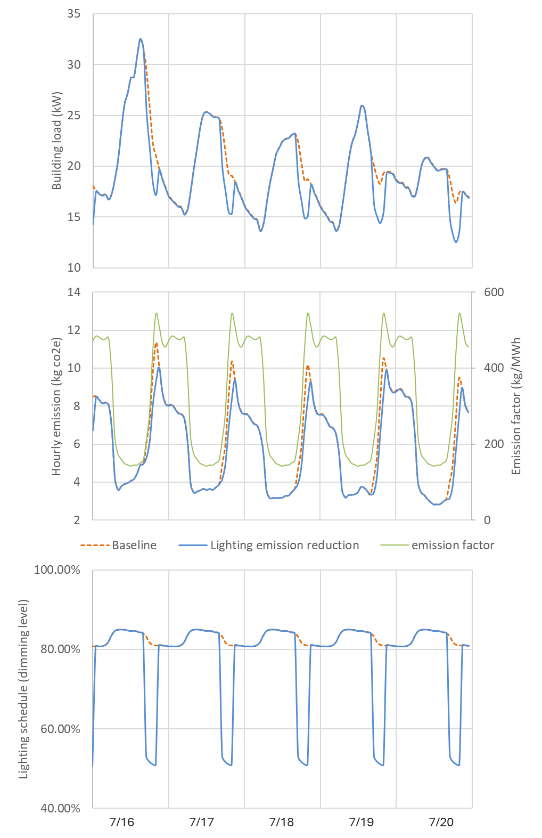
Figure 6. Comparison of load profiles, emission profiles, and lighting schedules (baseline and lighting load shed) for emission reduction for test small office model
The measure realizes emission savings through reducing lighting electricity usage, but the impact of electric load reduction on emission is relatively small because the significant timing of emission (corresponding to high emission factors) is staggered to significant (peak) electric load. The absolute magnitude of load change is small when reducing load during peak emission time, likely in or close to nonworking hours as shown in Figure 6, while the resulting emission change would also be small even if more load could be reduced during peak load time due to smaller emission factors in the periods.
  - Stock Demand Flexibility Performance for Emissions Reduction
From this section we are presenting and discussing stock-level impacts in various prospectives. This section illustrates some aggregated statistics of metrics that are determined to be essential to evaluate the performance of the demand flexibility measure, but they may not depict all of the nuances with demand flexibility.
    - Stock Greenhouse Gas Emissions Impacts
Figure 7 shows the annual stock-level impact of the measure with emission reduction objective on greenhouse gas emissions and presents approximately 0.3%–0.5% emission reductions for three grid electricity scenarios. Note that these results are at stock level, including non-applicable buildings. For applicable buildings, more granular results are shown in Figure 8 at the seasonal daily average level, for selected Cambium LRMER Mid Case 15-Year scenario. The savings performance increases to 1.6%-2.0% depending on the seasons.
The emission reductions are mostly attributed to the resulting reduced electricity consumption. The small impact on emission is mainly due to the inconsistent patterns of building electricity loads and emission factors, as well as the resulting emission profiles, as discussed in Section 5.1.2. In addition, the dispatched lighting load is small compared to total building load (less than 10% as shown in section 5.3), and thus the resulting emissions savings are small. The electricity emissions are dispatched daily following the proposed demand flexibility strategy, and the annual aggregate results would vary if other emissions reduction strategies were applied.
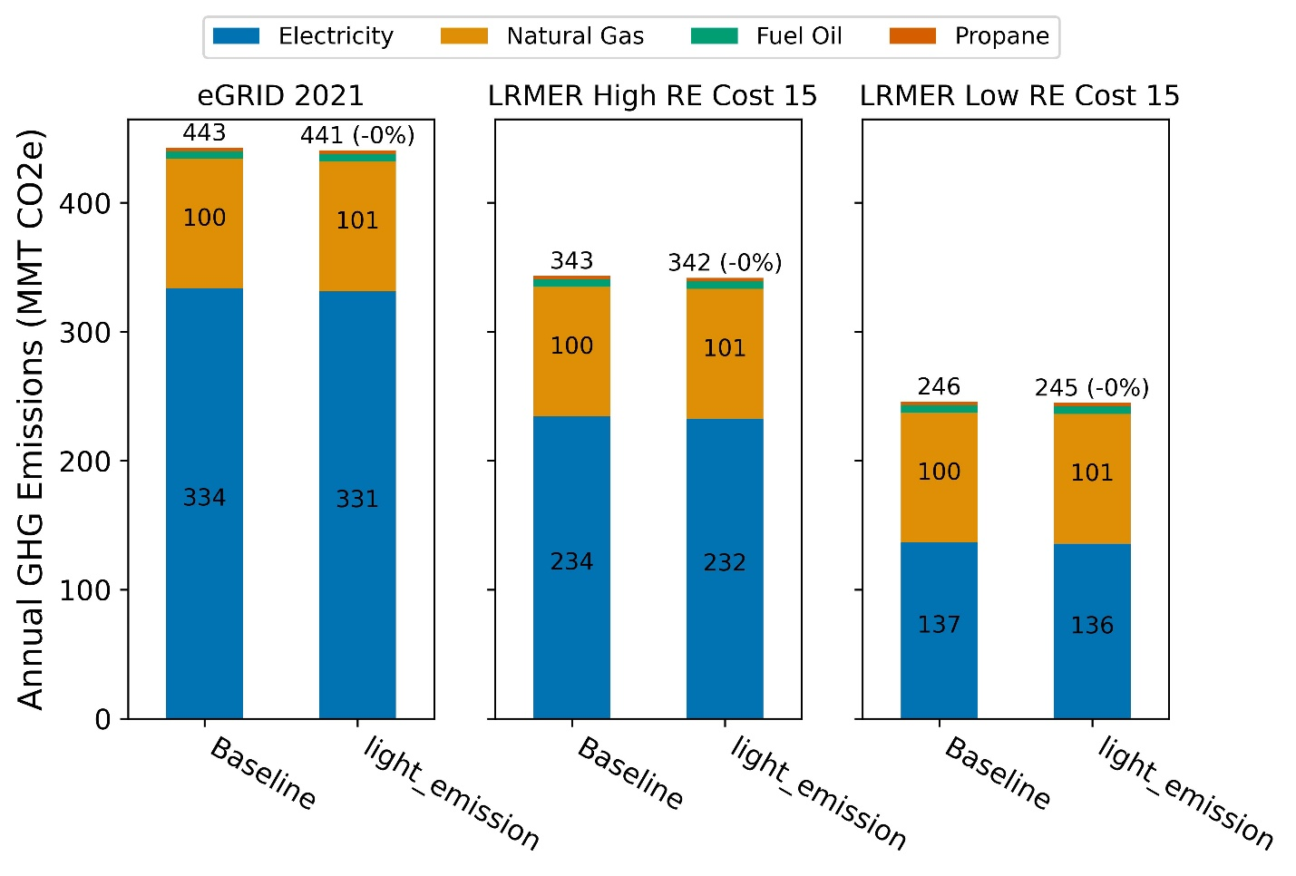
Figure 7. Greenhouse gas emissions comparison of the ComStock baseline and the lighting control for emissions reduction scenario
Three electricity grid scenarios are presented: Cambium LRMER High RE Cost 15-Year, Cambium LRMER Low RE Cost 15-Year, and eGrid.
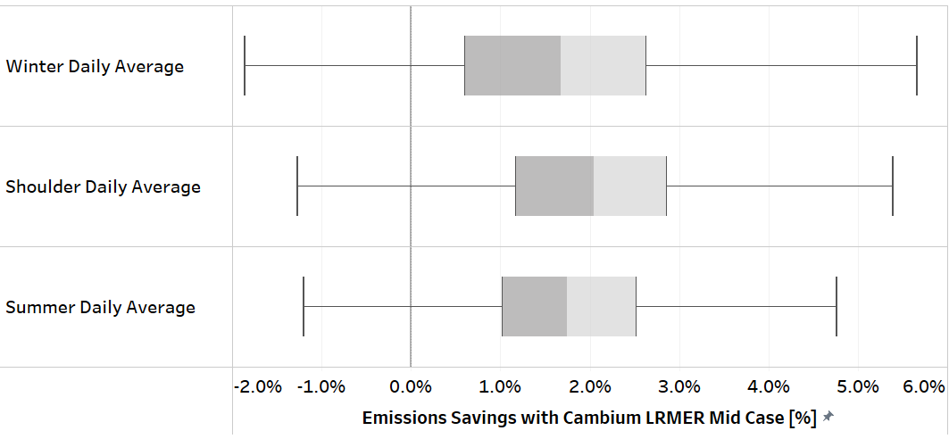
Figure 8. Distributions of percentages of daily emissions reduction by season compared to the baseline scenario, with Cambium LRMER Mid Case 15-Year scenario
  - Stock Energy Impacts
The lighting control for emissions reduction measure with peak load reduction objective demonstrates 0.52% total site energy savings (22.5 trillion Btu [TBtu]) for the U.S. commercial building stock modeled in ComStock, and 1.10% savings for the applicable buildings, as shown in Figure 9. The savings contributions by end use and fuel type are summarized in Table 7 and illustrated in Figure 9.
Table 77. Summary of Site Energy Savings From Upgrade Measure Application vs. the ComStock Baseline
End Use/Fuel Type | Percent Site Energy Savings (All Buildings) |  | Percent Site Energy Savings (Applicable Buildings Only) |  | Absolute Site Energy Savings (TBtu)
Total Energy | 0.33% |  | 0.69% |  | 16.1
Total Electricity | 0.71% |  | 1.48% |  | 22.0
Total Natural Gas | -0.36% |  | -0.81% |  | -5.4
Natural Gas Heating | -0.54% |  | -0.86% |  | -5.4
Electric Heating | -0.61% |  | -1.13% |  | -1.1
Electric Cooling | 0.31% |  | 0.62% |  | 2.2
Electric Fans | 0.11% |  | 0.22% |  | 0.6
Interior Lighting | 4.87% |  | 9.67% |  | 20.3
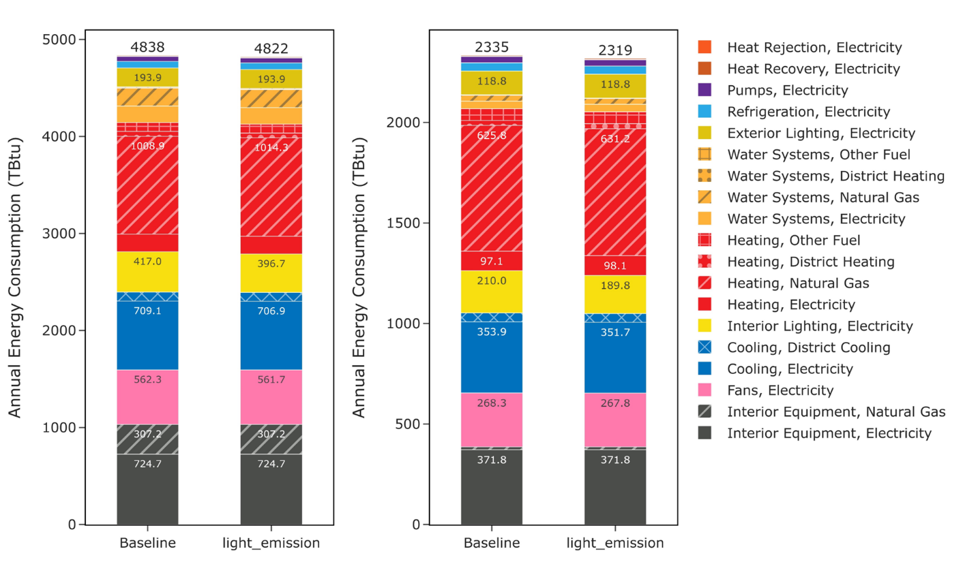
Figure 9. Comparison of annual site energy consumption between the ComStock baseline and the lighting control for emissions reduction measure scenario, for the whole stock (left) and applicable buildings only (right). Energy consumption is categorized both by fuel type and end use.
The measure focuses on load shed for electric lighting systems in offices, schools, and warehouses, so the energy savings are less prominent at the stock level, which includes various non-applicable building types and fuel types. The site energy increase for natural gas and electric heating are mainly attributed to the increased heating load caused by lowered heat gain from lighting equipment, which is expected whenever internal loads are reduced. On the other hand, the cooling load is reduced for the same reason, and results in cooling electricity savings. The objective of the measure is to provide demand flexibility by shaving load peaks on a daily basis instead of improving energy efficiency (for both peak load reduction and emission reduction objectives), so the energy savings are treated as side benefits from the measure. However, the developed load shed measure is not exclusive from other energy efficiency measures; it could be integrated with them to provide demand flexibility while saving energy.
  - Stock Utility Bill Impacts
Figure 10 shows the bill comparison of baseline and measure impact in the stock level. Overall, it shows around 1% savings among the different rates, mainly contributed to electricity bill savings due to reduced electricity consumption. Compared to Figure 11, the stock-level bill savings are diluted, as 32% of the stock (for building area prospective) is not applicable to the measure.
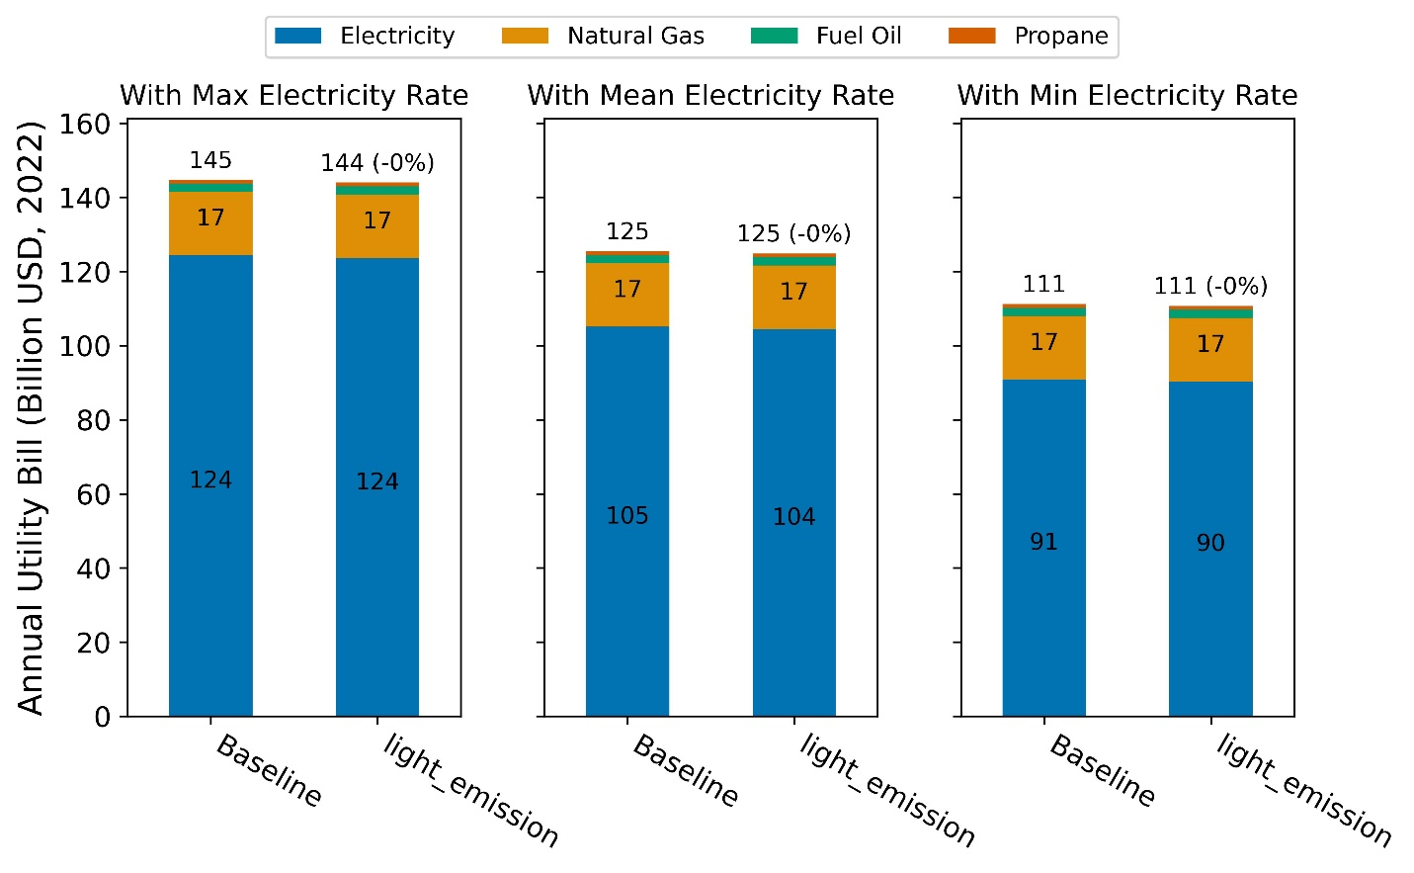
Figure 10. Stock annual utility bill comparison of the ComStock baseline and the lighting control for emissions reduction scenario. Three sets of bill costs are presented: maximum electricity rate, mean electricity rate, and minimum electricity rate.
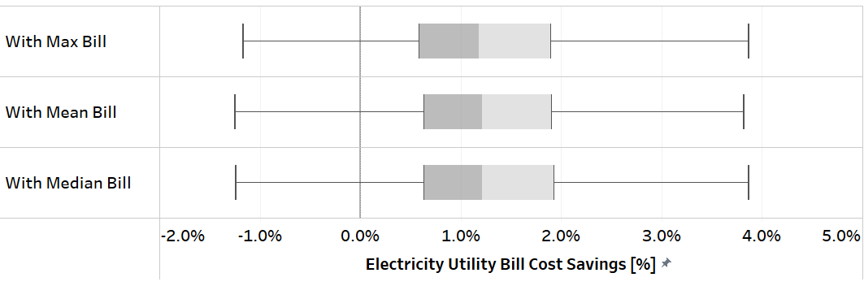
Figure 11. Distribution of annual electricity bill savings compared to the baseline model for maximum, mean, and median bills (for applicable buildings)
Figure 11 shows the distribution of annual bill savings for the default scenario with respect to the maximum, mean, and median bill costs among all considered utility rate structures. All show positive bill savings of around 1%. Savings corresponding to the maximum bill are generally smaller than the mean or median ones, indicating that the rate structure resulting in the maximum bill typically benefits less in peak reduction or has no portion related to demand. The bill savings are primarily from:
- Net energy use reduction (major).
- Time-of-use rates that have matched time of peak prices with the peak windows on a monthly average (there could be negative savings for time-of-use rates that have peak prices outside of the daily peak window identified by this measure).
- Applicable monthly or seasonal demand charge reduction.
These savings underestimate the benefits from a measure targeting daily peak load reduction, as most rate structures consider peak demand charge on a monthly or seasonal basis, while demand response programs or rate structures including demand response incentives that favor daily demand flexibility control are currently not able to be directly integrated into ComStock analysis.
Figure 12 shows the breakdown of savings by fuel types for applicable buildings. Again, the electricity bill savings result directly from the net savings of reduced lighting electricity consumption and increased heating electricity usage, while the negligible increase in site energy for nonelectric fuels are mainly caused by increased heating demand for nonelectric HVAC heating equipment, which present in around 20%-40% of applicable floor area depending on building types in the stock level.
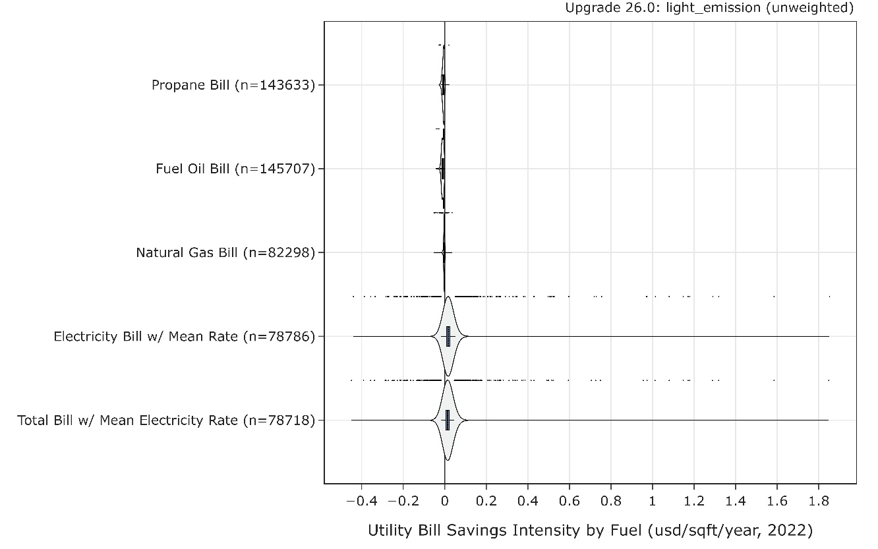
Figure 12. Percent bill savings for ComStock models with the lighting control for emissions reduction upgrade by fuel types. The data points that appear above some of the distributions indicate outliers in the distribution, meaning they fall outside 1.5 times the interquartile range. The value for n indicates the number of ComStock models that were applicable for energy savings for the fuel type category.
  - Site Energy Savings Distributions
This section discusses site energy consumption for quality assurance/quality control purposes. Note that site energy savings can be useful for these purposes, but other factors should be considered when drawing conclusions, as they do not necessarily translate proportionally to source energy savings, greenhouse gas emissions avoided, or energy cost.
Figure 17 and Figure 18 show the percent site energy and energy use intensity savings distributions by end use and fuel types, respectively. Percent savings provide relative impact of the measure at the individual building level, while site energy use intensity savings provide absolute (or aggregated) scale of impact. The breakdowns show consistent conclusion drawn in the energy and bill impact sections (5.3 and 5.4)—the measure benefits mainly from lighting and cooling electricity savings while sacrificing savings from heating energy with various fuel types.
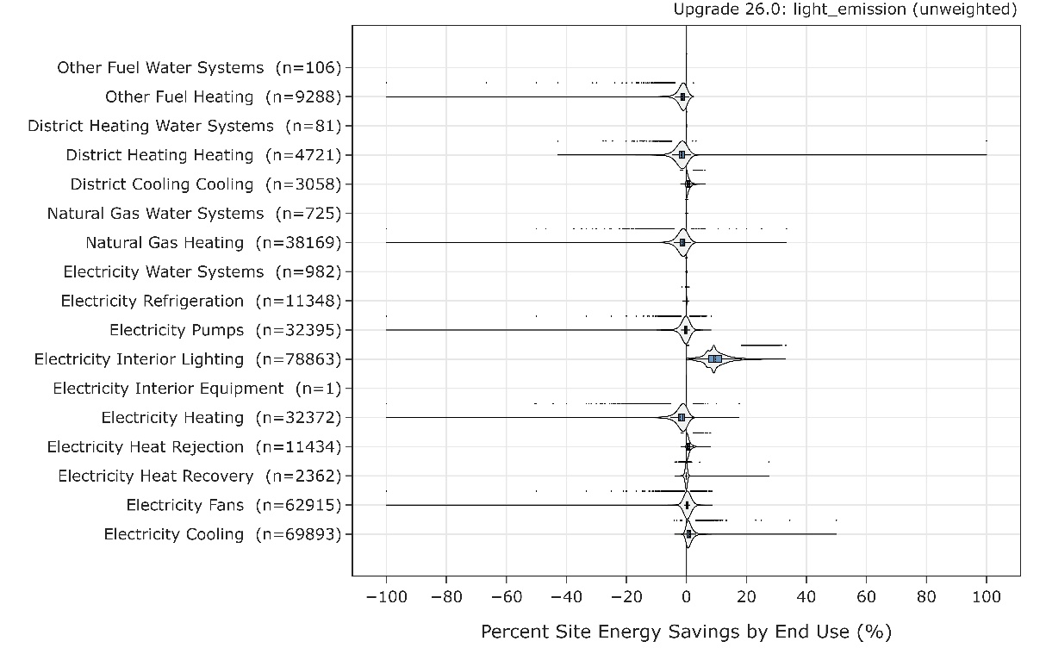
Figure 17. Percent site energy savings distribution for ComStock models with applied measure scenario by end use and fuel type. The data points that appear above some of the distributions indicate outliers in the distribution, meaning they fall outside 1.5 times the interquartile range. The value for n indicates the number of ComStock models that were applicable for energy savings for the fuel type category.
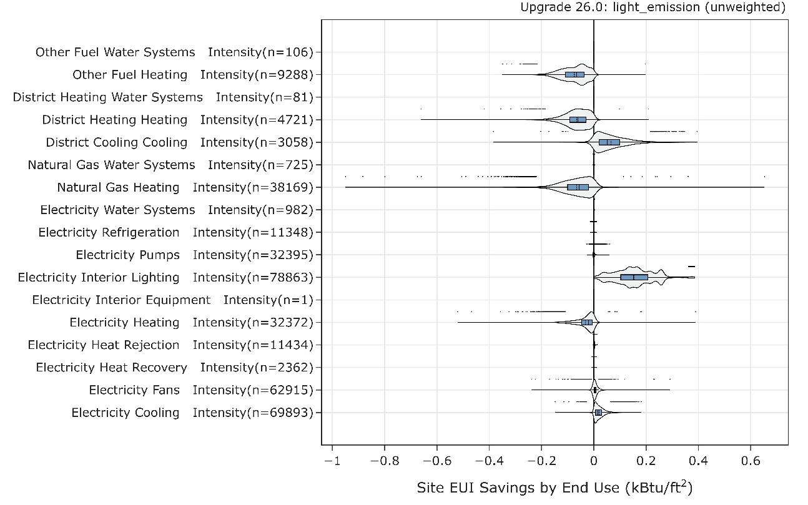
Figure 18. Percent site energy use intensity savings distribution for ComStock models with applied measure scenario by end use and fuel type. The data points that appear above some of the distributions indicate outliers in the distribution, meaning they fall outside 1.5 times the interquartile range. The value for n indicates the number of ComStock models that were applicable for energy savings for the fuel type category.

References
[1] H. Wang, S. Wang, and K. Shan, “Experimental study on the dynamics, quality and impacts of using variable-speed pumps in buildings for frequency regulation of smart power grids,” Energy, vol. 199, p. 117406, May 2020, doi: 10.1016/j.energy.2020.117406.
[2] E. M. Burger and S. J. Moura, “Generation following with thermostatically controlled loads via alternating direction method of multipliers sharing algorithm,” Electric Power Systems Research, vol. 146, pp. 141–160, May 2017, doi: 10.1016/j.epsr.2016.12.001.
[3] D. Wu, J. Lian, Y. Sun, T. Yang, and J. Hansen, “Hierarchical control framework for integrated coordination between distributed energy resources and demand response,” Electric Power Systems Research, vol. 150, pp. 45–54, Sep. 2017, doi: 10.1016/j.epsr.2017.05.002.
[4] M. Olama, T. Kuruganti, J. Nutaro, and J. Dong, “Coordination and Control of Building HVAC Systems to Provide Frequency Regulation to the Electric Grid,” Energies, vol. 11, no. 7, p. 1852, Jul. 2018, doi: 10.3390/en11071852.
[5] K. Wang, R. Yin, L. Yao, J. Yao, T. Yong, and N. Deforest, “A Two-Layer Framework for Quantifying Demand Response Flexibility at Bulk Supply Points,” IEEE Trans. Smart Grid, vol. 9, no. 4, pp. 3616–3627, Jul. 2018, doi: 10.1109/TSG.2016.2636873.
[6] H. Hao, B. M. Sanandaji, K. Poolla, and T. L. Vincent, “Aggregate Flexibility of Thermostatically Controlled Loads,” IEEE Trans. Power Syst., vol. 30, no. 1, pp. 189–198, Jan. 2015, doi: 10.1109/TPWRS.2014.2328865.
[7] W. Zhang, J. Lian, C.-Y. Chang, and K. Kalsi, “Aggregated Modeling and Control of Air Conditioning Loads for Demand Response,” IEEE Trans. Power Syst., vol. 28, no. 4, pp. 4655–4664, Nov. 2013, doi: 10.1109/TPWRS.2013.2266121.
[8] D. Zhang, S. Li, M. Sun, and Z. O’Neill, “An Optimal and Learning-Based Demand Response and Home Energy Management System,” IEEE Trans. Smart Grid, vol. 7, no. 4, pp. 1790–1801, Jul. 2016, doi: 10.1109/TSG.2016.2552169.
[9] H. Hao, D. Wu, J. Lian, and T. Yang, “Optimal Coordination of Building Loads and Energy Storage for Power Grid and End User Services,” IEEE Trans. Smart Grid, vol. 9, no. 5, pp. 4335–4345, Sep. 2018, doi: 10.1109/TSG.2017.2655083.
[10] M. Liu and Y. Shi, “Model Predictive Control of Aggregated Heterogeneous Second-Order Thermostatically Controlled Loads for Ancillary Services,” IEEE Trans. Power Syst., vol. 31, no. 3, pp. 1963–1971, May 2016, doi: 10.1109/TPWRS.2015.2457428.
[11] M. Di Somma et al., “Multi-objective design optimization of distributed energy systems through cost and exergy assessments,” Applied Energy, vol. 204, pp. 1299–1316, Oct. 2017, doi: 10.1016/j.apenergy.2017.03.105.
[12] J. Neubauer and M. Simpson, “Deployment of Behind-The-Meter Energy Storage for Demand Charge Reduction,” NREL/TP--5400-63162, 1168774, Jan. 2015. doi: 10.2172/1168774.
[13] K. Klein, S. Herkel, H.-M. Henning, and C. Felsmann, “Load shifting using the heating and cooling system of an office building: Quantitative potential evaluation for different flexibility and storage options,” Applied Energy, vol. 203, pp. 917–937, Oct. 2017, doi: 10.1016/j.apenergy.2017.06.073.
[14] S. H. Kim, “Building demand-side control using thermal energy storage under uncertainty: An adaptive Multiple Model-based Predictive Control (MMPC) approach,” Building and Environment, vol. 67, pp. 111–128, Sep. 2013, doi: 10.1016/j.buildenv.2013.05.005.
[15] S. B. Sadineni and R. F. Boehm, “Measurements and simulations for peak electrical load reduction in cooling dominated climate,” Energy, vol. 37, no. 1, pp. 689–697, Jan. 2012, doi: 10.1016/j.energy.2011.10.026.
[16] M. Di Somma, G. Graditi, E. Heydarian-Forushani, M. Shafie-khah, and P. Siano, “Stochastic optimal scheduling of distributed energy resources with renewables considering economic and environmental aspects,” Renewable Energy, vol. 116, pp. 272–287, Feb. 2018, doi: 10.1016/j.renene.2017.09.074.
[17] J. Yao, X. Liu, W. He, and A. Rahman, “Dynamic Control of Electricity Cost with Power Demand Smoothing and Peak Shaving for Distributed Internet Data Centers,” in 2012 IEEE 32nd International Conference on Distributed Computing Systems, Macau, China: IEEE, Jun. 2012, pp. 416–424. doi: 10.1109/ICDCS.2012.67.
[18] U.S. Energy Information Administration, “2018 Commercial Buildings Energy Consumption Survey (CBECS).” [Online]. Available: https://www.eia.gov/consumption/commercial/
[19] DOE, “GEB Technical Reports,” Energy.gov. Accessed: Mar. 18, 2024. [Online]. Available: https://www.energy.gov/eere/buildings/geb-technical-reports
[20] “Evaluation of Advanced Lighting Control Systems in a Working Office Environment”.
[21] J. Shackelford, A. Robinson, and F. Rubinstein, “Retrofit Demonstration of LED Fixtures with Integrated Sensors and Controls”.
[22] S. H. A. Begemann, G. J. Van Den Beld, and A. D. Tenner, “Daylight, artificial light and people in an office environment, overview of visual and biological responses,” International Journal of Industrial Ergonomics, vol. 20, no. 3, pp. 231–239, Sep. 1997, doi: 10.1016/S0169-8141(96)00053-4.
[23] K. M. Kryszczuk and P. R. Boyce, “Detection of Slow Light Level Reduction,” Journal of the Illuminating Engineering Society, vol. 31, no. 2, pp. 3–10, Jul. 2002, doi: 10.1080/00994480.2002.10748387.
[24] Y. Akashi and J. Neches, “Detectability and Acceptability of Illuminance Reduction for Load Shedding,” Journal of the Illuminating Engineering Society, vol. 33, no. 1, pp. 3–13, Jan. 2004, doi: 10.1080/00994480.2004.10748422.
[25] R. Hu, K. M. Hegadoren, X. Wang, and X. Jiang, “An investigation of light and sound levels on intensive care units in China,” Australian Critical Care, vol. 29, no. 2, pp. 62–67, May 2016, doi: 10.1016/j.aucc.2015.08.001.
[26] S. A. Husen, A. Pandharipande, L. Tolhuizen, Ying Wang, and Meng Zhao, “Lighting systems control for demand response,” in 2012 IEEE PES Innovative Smart Grid Technologies (ISGT), Washington, DC, USA: IEEE, Jan. 2012, pp. 1–6. doi: 10.1109/ISGT.2012.6175703.
[27] F. Rubinstein and S. Kiliccote, “Demand Responsive Lighting: A Scoping Study,” LBNL--62226, 927027, Jan. 2007. doi: 10.2172/927027.
[28] C. DiLouie, “Lighting and Grid-Interactive Buildings,” Lighting Controls Association, Sep. 24, 2021. [Online]. Available: https://lightingcontrolsassociation.org/2021/09/24/grid-interactive-buildings/
[29] A. Abate and P. Morante, “DEMONSTRATION OF A LOW COST AUTOMATION OF LIGHTING AS A DEMAND RESPONSE RESOURCE,” THE LIGHTING RESEARCH CENTER AT RENSSELAER POLYTECHNIC INSTITUTE, 2011.
[30] A. Parker et al., “ComStock Reference Documentation (V.1),” NREL/TP--5500-83819, 1967948, MainId:84592, Mar. 2023. doi: 10.2172/1967948.
[31] E. Wilson et al., “End-Use Load Profiles for the U.S. Building Stock: Methodology and Results of Model Calibration, Validation, and Uncertainty Quantification,” NREL/TP-5500-80889, 1854582, MainId:78667, Mar. 2022. doi: 10.2172/1854582.
[32] M. Deru et al., “U.S. Department of Energy Commercial Reference Building Models of the National Building Stock,” NREL/TP-5500-46861, 1009264, Feb. 2011. doi: 10.2172/1009264.
[33] A. T. F. for B. Decarbonization and K. Carbonnier, Grid-interactive Buildings for Decarbonization: Design and Operation Resource Guide. ASHRAE, 2023. [Online]. Available: https://books.google.com/books?id=Je0m0AEACAAJ
[34] NREL, “Cambium | Energy Analysis.” [Online]. Available: https://www.nrel.gov/analysis/cambium.html
[35] US EPA, “Emissions & Generation Resource Integrated Database (eGRID).” [Online]. Available: https://www.epa.gov/egrid
[36] E. Present, P. Gagnon, E. J. H. Wilson, N. Merket, P. R. White, and S. Horowitz, “Choosing the Best Carbon Factor for the Job: Exploring Available Carbon Emissions Factors and the Impact of Factor Selection,” Aug. 2022, [Online]. Available: https://www.osti.gov/biblio/1891472
[37] G. Vijayakumar and others, “ANSI/RESNET/ICC 301-2022-Standard for the Calculation and Labeling of the Energy Performance of Dwelling and Sleeping Units using an Energy Rating Index,” Oceanside, CA, 2022.
[38] U.S. Energy Information Administration, “Use of natural gas - U.S. Energy Information Administration (EIA).” [Online]. Available: https://www.eia.gov/energyexplained/natural-gas/use-of-natural-gas.php
[39] U.S. Energy Information Administration, “No. 2 Distillate Prices - Residential.” [Online]. Available: https://www.eia.gov/dnav/pet/pet_pri_dist_a_epd2_prt_dpgal_a.htm
[40] S. Ong and R. McKeel, “National Utility Rate Database: Preprint,” NREL/CP-6A20-54633, 1050105, Aug. 2012. doi: 10.2172/1050105.
[41] U.S. Energy Information Administration, “EIA - Independent Statistics and Analysis.” [Online]. Available: https://www.eia.gov/totalenergy/data/browser/index.php?tbl=T07.06#/?f=A

Appendix
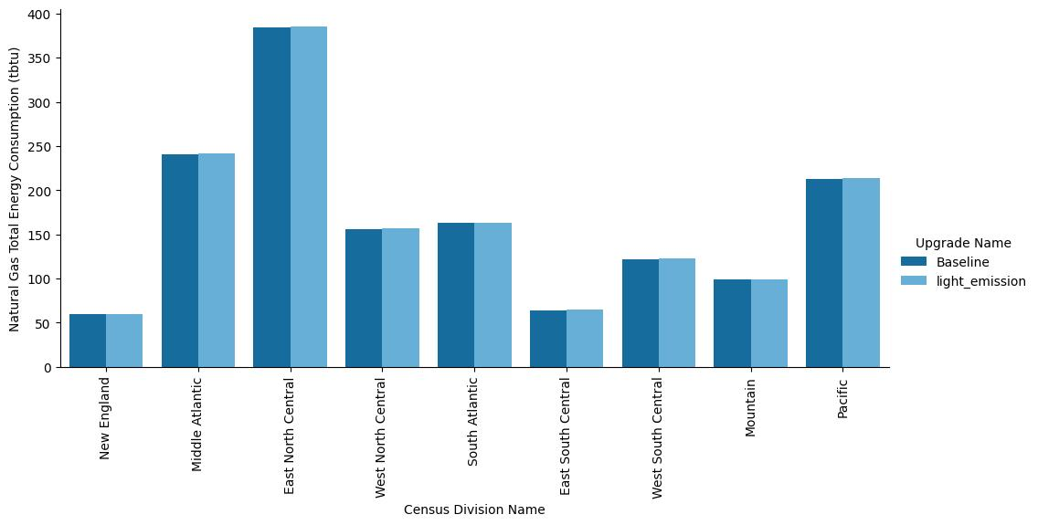
Figure A-1. Site annual natural gas consumption of the ComStock baseline and the measure scenario by census division
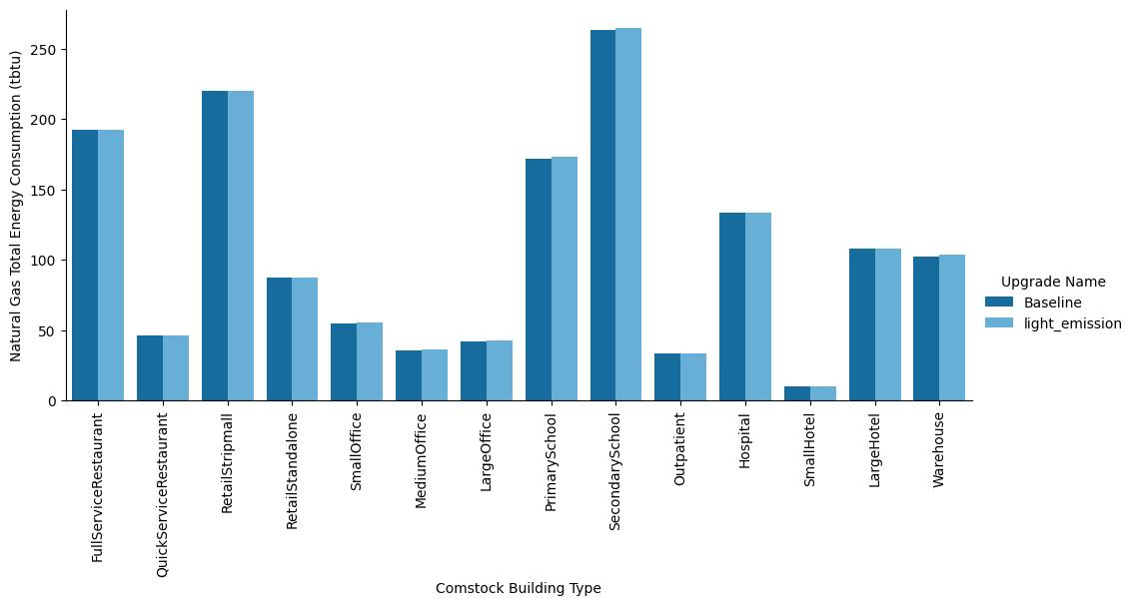
Figure A-2. Site annual natural gas consumption of the ComStock baseline and the measure scenario by building type
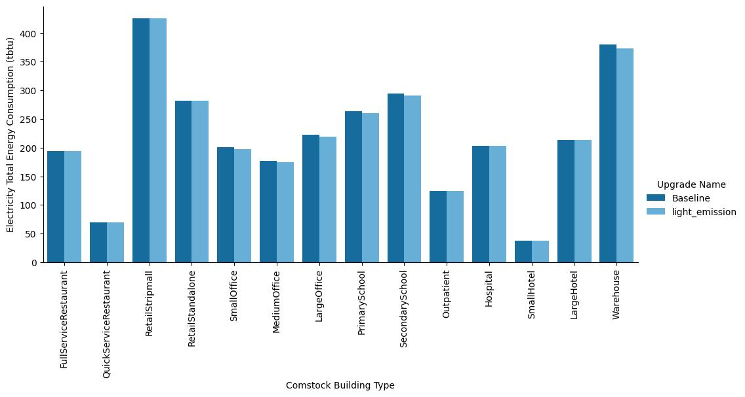
Figure A-3. Site annual electricity consumption of the ComStock baseline and the measure scenario by building type
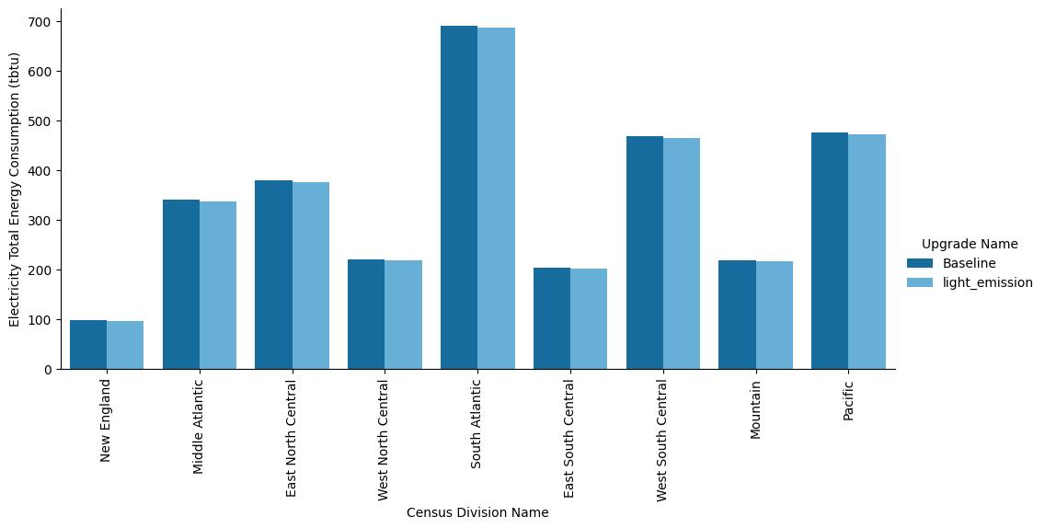
Figure A-4. Site annual electricity consumption of the ComStock baseline and the measure scenario by census division

